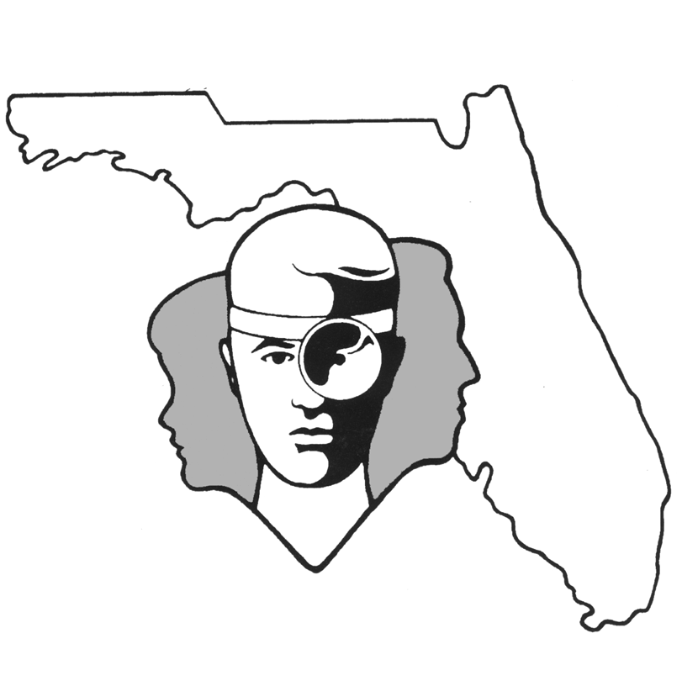
TALLAHASSEE EAR, NOSE & THROAT - HEAD & NECK SURGERY, P.A.

www.TallyENT.com Office Phone: 850-877-0101

FUNCTIONAL ENDOSCOPIC SINUS SURGERY (FESS)

Your surgeon has suggested surgery for correction of your sinus disease. Generally, surgery in indicated for:
1. Recurrent episodes of acute sinusitis which occur frequently enough to disrupt your lifestyle.
2. Chronic sinusitis unresponsive to antibiotics and/or irrigation of the sinuses.
3. Biopsy or removal of a mass or polyp within the sinuses.

These are the main reasons to perform FESS, but occasionally other problems arise which necessitate this surgery. Generally, a CT scan will be done before surgery to document which sinuses are affected and also to identify your individual anatomy.

The surgeon may have determined that your maxillary sinus is involved with one of the above problems. The maxillary sinuses are located beneath your cheekbones, above your upper teeth. The maxillary sinus drains into what is called the osteomeatal complex, which is an opening on the outer wall of the nasal cavity. The surgery, a “maxillary antrotomy”, is designed to enlarge this natural opening and thereby prevent it from swelling shut when the lining of the nose is inflamed or infected. The procedure may be done through the nose using a fiberoptic endoscope and small instruments for biting away the bone around the osteomeatal complex or a balloon may be used to open the sinus.

Another area which your surgeon may have determined needs correction is the ethmoid sinuses. These sinuses are located between your eyes and are a honeycomb of 13 to 20 individual sinuses, each with its own individual opening. The ethmoids are opened surgically to create one large cavity which drains directly down into the nose. This operation is called an “ethmoidectomy”.

Infrequently the frontal sinus, which is located just behind the center portion of your forehead, also needs to be opened endoscopically. This sinus drains directly down into the nasal cavity, usually just in front of where the maxillary sinus drains. The surgical procedure (frontal sinusotomy) opens the drainage duct more widely into the nose. Sometimes, a 1-2 mm opening through the skin of the forehead may be used to “flush” the sinus through its natural passage in the nose.

The last sinus which is occasionally opened endoscopically is the sphenoid sinus, which is located in the direct center of the skull. The sphenoid sinus is opened by removing the front wall of the sinus and allowing it to drain directly into the nasal passageway. This procedure is termed “sphenoidectomy”.

Frequently a combination of the different sinuses is involved with the disease process, and often more than one is opened at a single surgical procedure. Occasionally, however, only one is involved and is treated individually at the time of the surgery.

The potential complications of endoscopic surgery depend upon which sinuses are opened. When the maxillary and ethmoid sinuses are involved, there can be damage to the eye since it is directly adjacent to both of these sinuses. Complications of surgery may include the following:
1. Excessive tearing postoperatively if the duct that drains the eye into the nose is disrupted.
2. Escape of air from the nose into the tissues around the eye, causing it to crackle to the touch
for several days.
3. Bleeding into the tissue around the eye, causing “black eyes”.
4. Bleeding into the eye, which could potentially cause blindness.
5. Injury to the nerve to the eye itself, causing blindness.
6. Double vision.
The incidence of any of these is less than one percent. Since we recognize the severity of these complications, in particular blindness, we will, of course, do our utmost to prevent them from occurring.

The operations involving the ethmoid, sphenoid, and frontal sinuses occur very near the brain and surrounding spinal fluid. All of these sinuses are being operated on with only one bone layer separating the sinus from the brain. Disruption of the bone around the skull can lead to air around the brain, leak of spinal fluid into the nose, meningitis, stroke, and even death. The risk of a leak occurring is around 1 in 1,000. Once again, we are very aware of the fact that this is a potential risk of surgery and do all in our power to prevent it from occurring. One of the reasons CT scans are performed before the surgery is to make sure there are no abnormalities in your particular anatomy that would predispose you to one of these major complications. We may also use a CT guidance system intraoperatively to further lessen the risk of complications.

Another problem which could potentially arise from surgery within the nasal cavity is a change in your sense of smell.

Sometimes a portion of what are called turbinates must also be removed to adequately perform the surgery. The turbinates are structures which hang down from the side wall of your nose into the nasal passageway. Generally, there are three to four of these on either side, and their function is to heat and humidify the air as you breathe it in through your nose. The middle turbinate on either side overhangs the area where the ethmoid, maxillary, and frontal sinuses drain. Sometimes, in order to adequately access the areas for surgery, a portion of this turbinate must be removed. Removal of a portion of the turbinates will increase the potential rate of bleeding. Overall, the risk of bleeding severely enough to require further packing after surgery is somewhere between one percent and five percent. Some bleeding is expected after sinus surgery, but it rarely requires a return to the operating room for control.

Because bleeding is a risk, we ask that you not take aspirin-containing products (example: BC or Goody’s headache powders, Anacin, Aspirin) for at least 7 days prior to your surgical procedure. We would like you not to take Advil, Nuprin, ibuprofen, Motrin, or similar arthritis drugs for 3 days before surgery. In addition, we would like you to discontinue any herbal supplements you take the week before surgery. Avoid the use of AFRIN or any nasal decongestant nose spray for 14-21 days prior to surgery.

Postoperatively you should not undergo any strenuous exertion, straining, vigorous nose blowing, or heavy lifting for two to three weeks after your surgery is performed. Generally, most people find that they have some discomfort for the first week or so after the surgery after which it becomes markedly decreased. Your surgeon will probably put you on antibiotics as well as postoperative pain medications. We will have you begin sinus irrigations (kits available over the counter: NEIL-MED, Neti Pot or Simply Saline) in order to minimize crusting in the nose. You may have a small pack in place, depending on your surgeon. This will be removed three to five days postoperatively.

You may also need to come back to the office postoperatively on a regular basis in order to keep the openings which we create surgically open and patent. After the sinuses are completely healed, there is an 80 to 95% chance that you will not have significant problems down the road with your sinuses. The exceptions to this are patients who have aspirin sensitivity, asthma, and nasal polyps, and who tend to have a much higher rate of recurrent nasal sinus problems.

